**1. Loop between checkboxes**

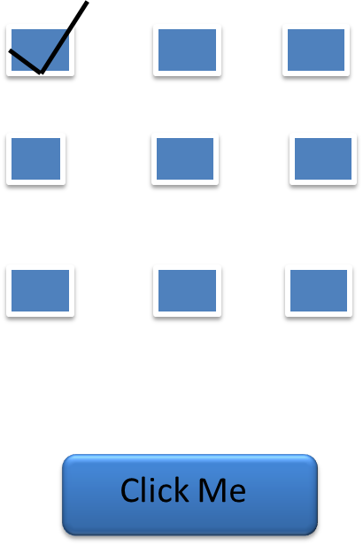

**2.** **Addition of two numbers**

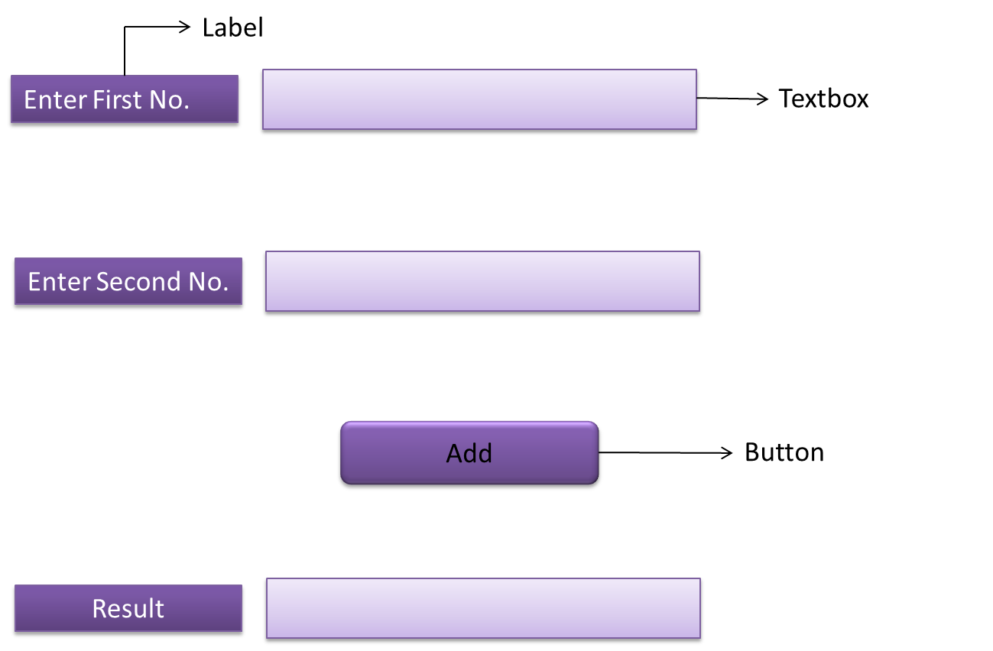

**3.** `**Changing the fore color of a text in a label**

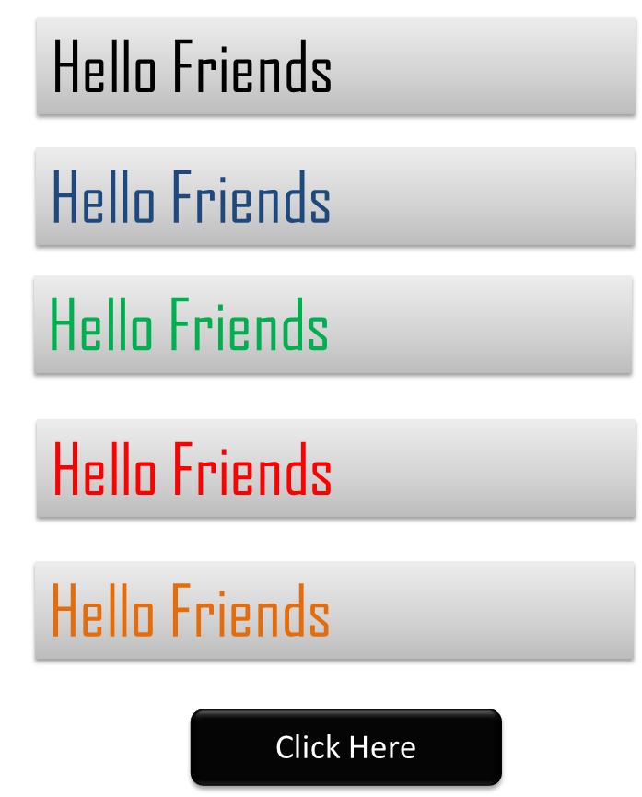

**4.** **Fore color and Back color change loop**

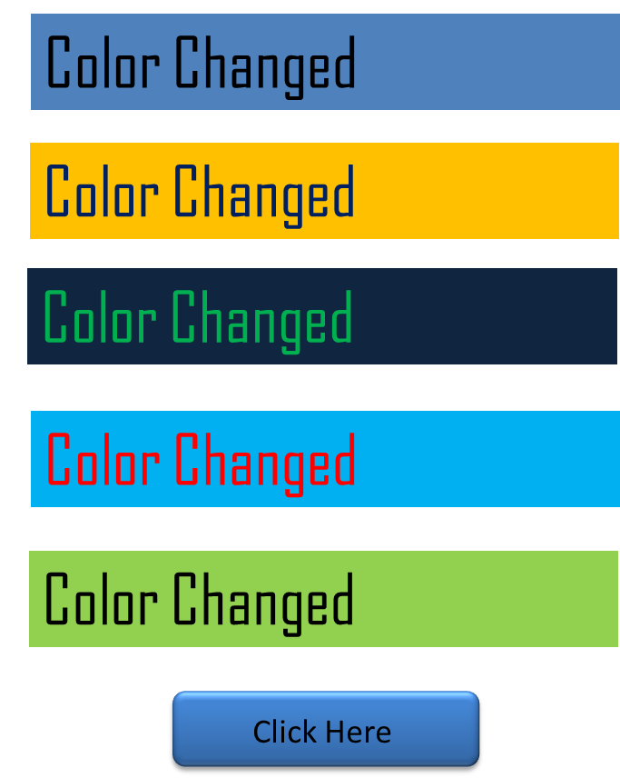

**5.**  **Swapping the items between Dropdown list**

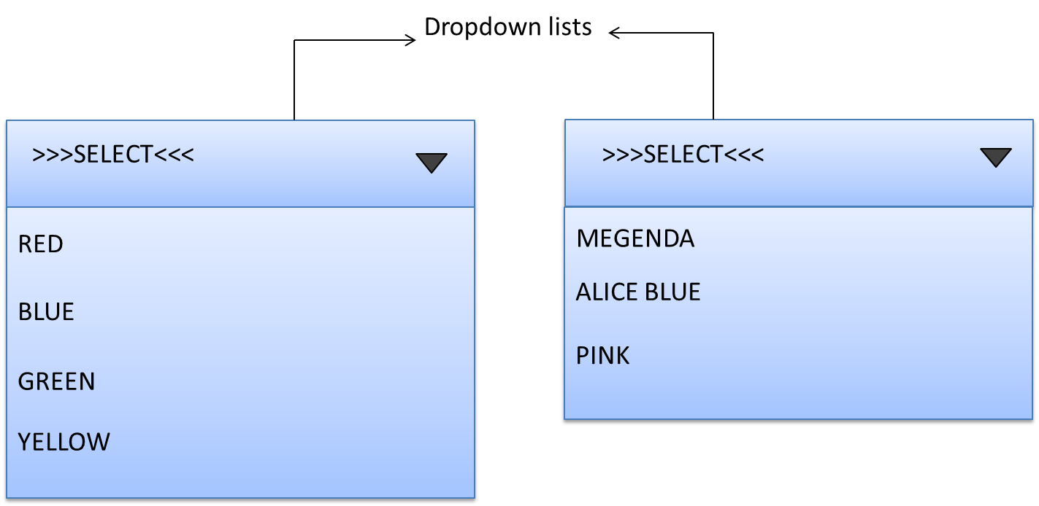

**6.**  **Time Difference**

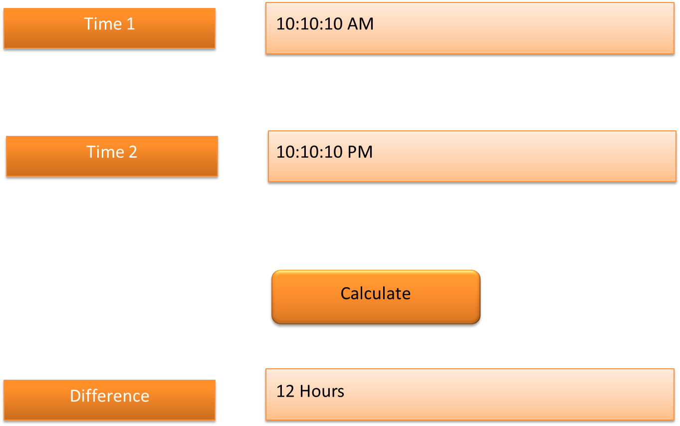

**7. Word Loop**

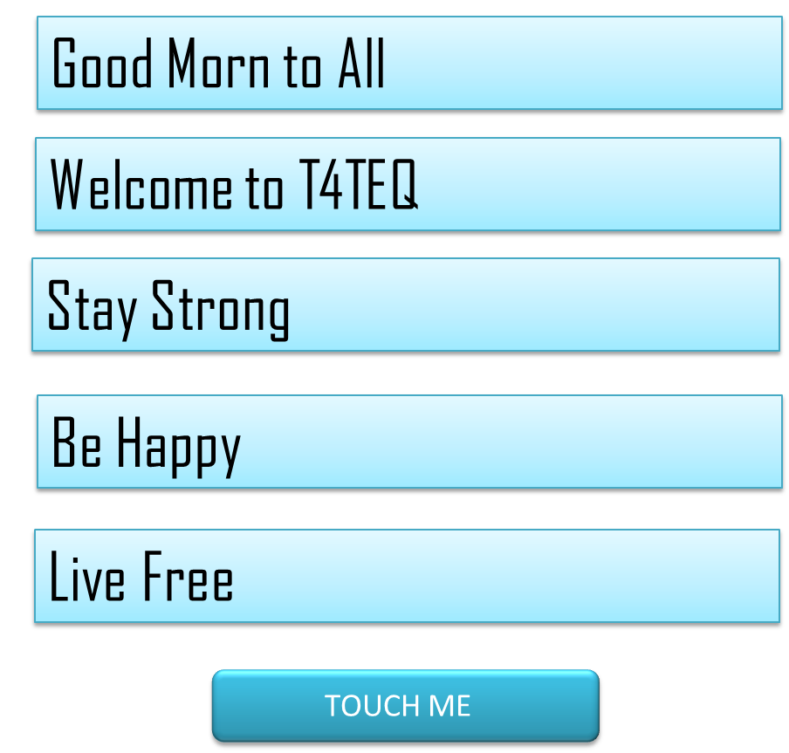

**8. Simple Calculator**

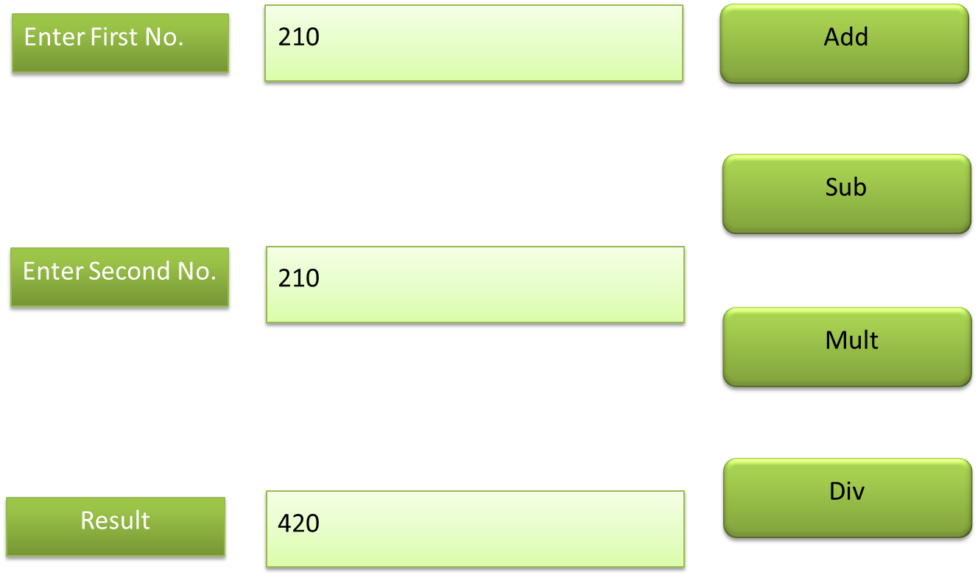

**9. Display Current Date and Time in a label**

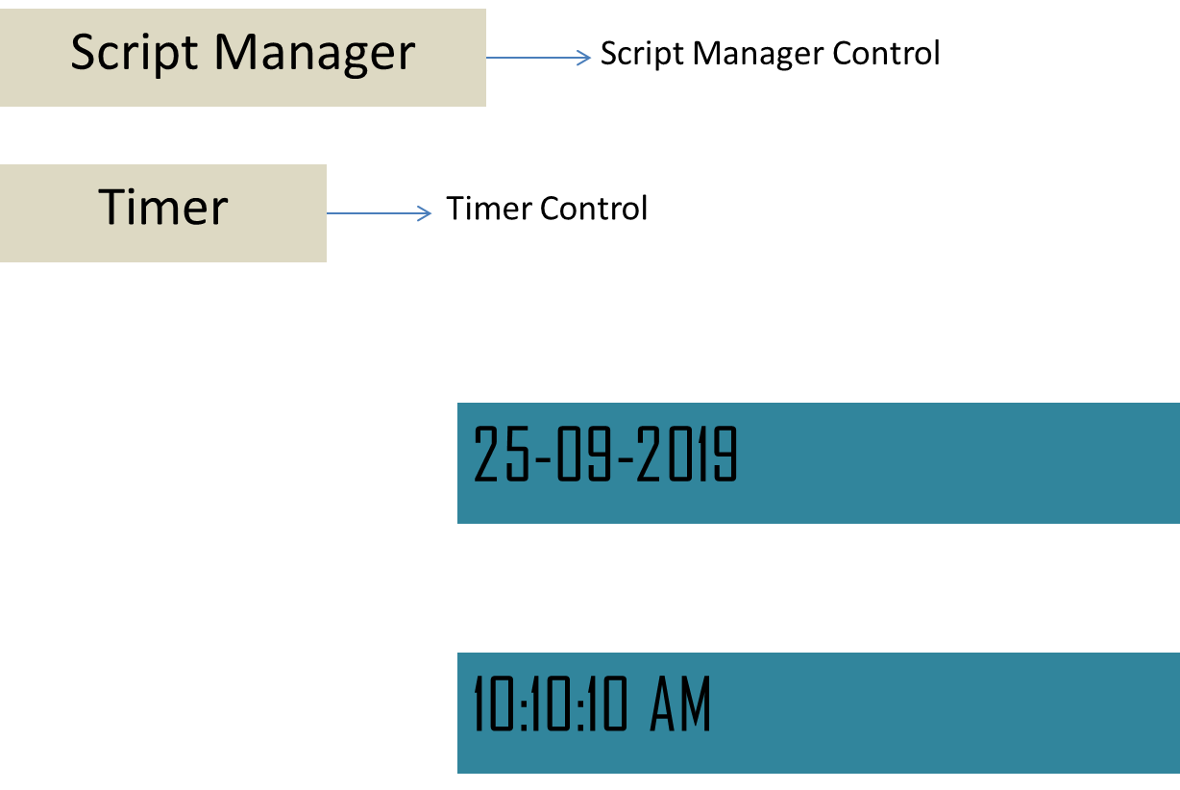

**10. Displaying a message using Message box**

